**School of Law Team Wins Inaugural Gender and the Law Moot Competition**

The Makerere University School of Law (SoL) team won the Inaugural National Inter-University Gender and Human Rights Law Moot competition held on the 24th November 2023 at Cavendish University, Kampala – Uganda. Namale Alyce, Soki Hildah and Ahebwa Simon Peter comprised the SoL team. The team also won best memorial and Alyce was awarded as best oralist of the competition.

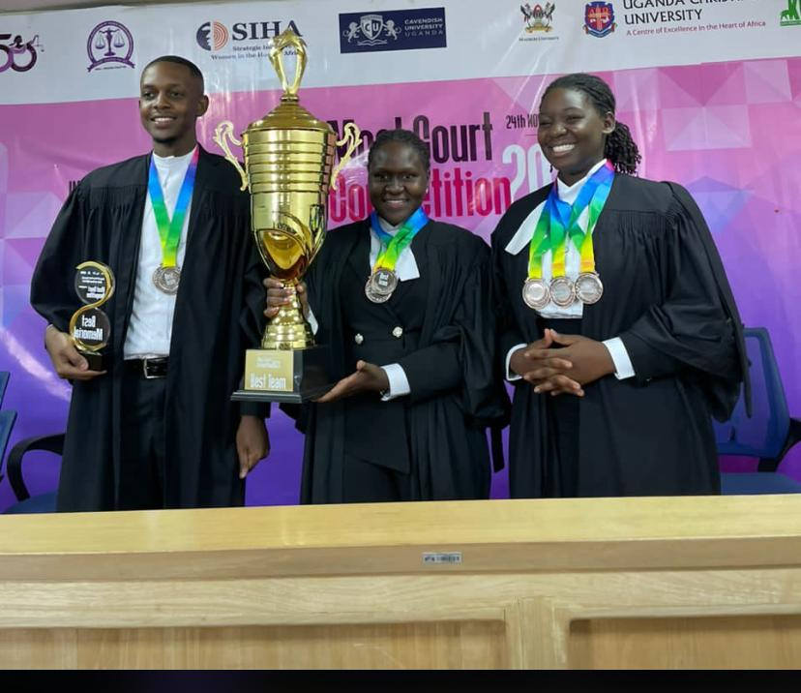

***L-R: Ahebwa Simon Peter, Soki Hildah and Namale Alyce with the trophy and medals***

The moot themed, ***‘Underscoring the State’s Due Diligence Obligation to End Violence Against Women and Girls’***, was organised by the Uganda Association of Women Lawyers (FIDA, Uganda) in association with the International Association of Women Judges, Uganda (AWJ-U).

The universities competing in the moot competition included Makerere University, Cavendish University, Kampala International University and Uganda Christian University. The moot was judged by Justices Susan Okalany, David Batema, Jane Alividza and Henrietta Wolayo.

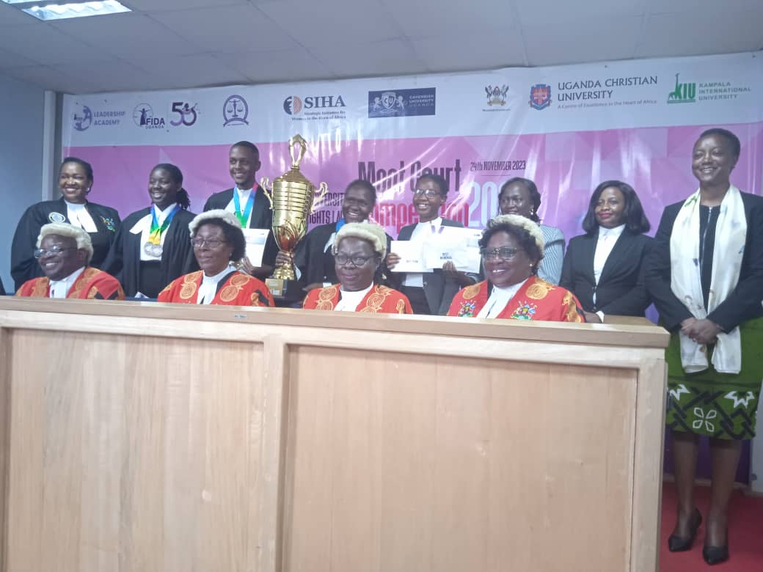***Winning team in a photo moment with the Judges of the competition***