School of Law presents Graduands at the 73rd Graduation Ceremony of Makerere University
Makerere University School of Law (SoL) presented graduands on the first day of Makerere University’s 73rd Graduation Ceremony held on the 13th February 2023 at the Freedom Square, Makerere University. A total of 249 graduands were presented by the School including (23) Master of Laws and (226) Bachelor of Laws. Master of Laws were awarded to 12 female and 11 males while the Bachelor of Laws awardees were 94 female and 132 males.
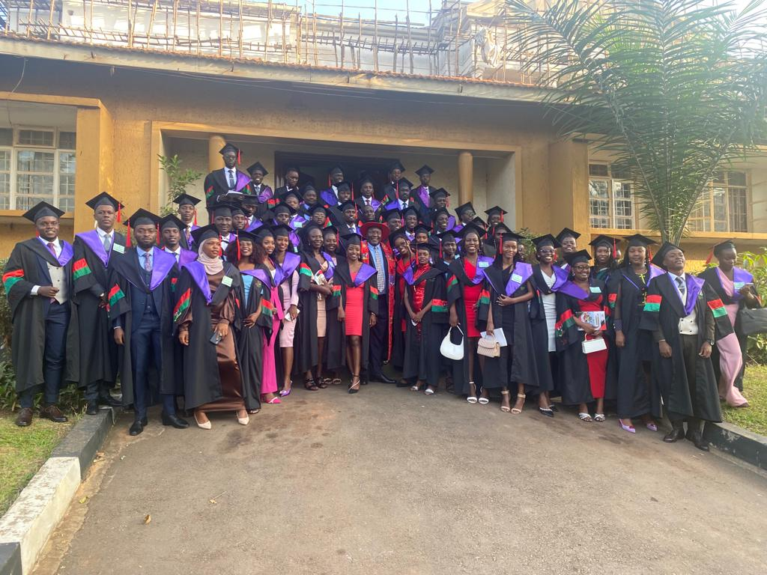
SoL graduands in a group photo with the Principal at the School of Law

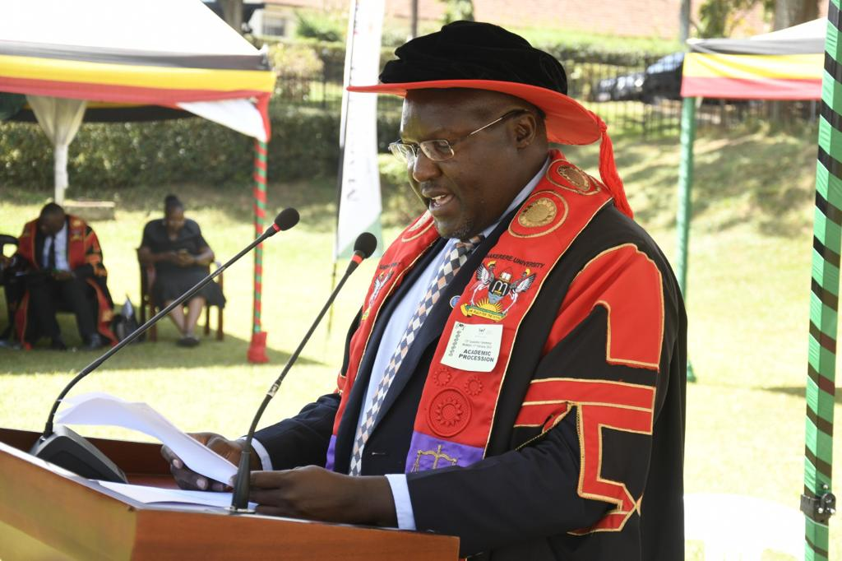
Professor Ronald Naluwairo, Principal – SoL presenting graduands at the 73rd Graduation Ceremony of Makerere University

Speaking to the congregation, Professor Barnabas Nawangwe – Vice Chancellor, Makerere University welcomed everyone to Makerere University’s 73rd Graduation. He said, ‘it gives me great pleasure to congratulate you upon reaching this milestone. Today marks the culmination of your hard work as graduands, as well as the sacrifices of the parents, guardians, sponsors, family and friends. So, take time off and celebrate’. The Vice Chancellor thanked all stakeholders for the continued support to Makerere University; he said, ‘we acknowledge that the milestones we registered over 100 years would not be possible without the close working relationship we have enjoyed with the Government of Uganda, the Ministry of Education and Sports, staff, alumni, students as well as development partners at national and global levels’.
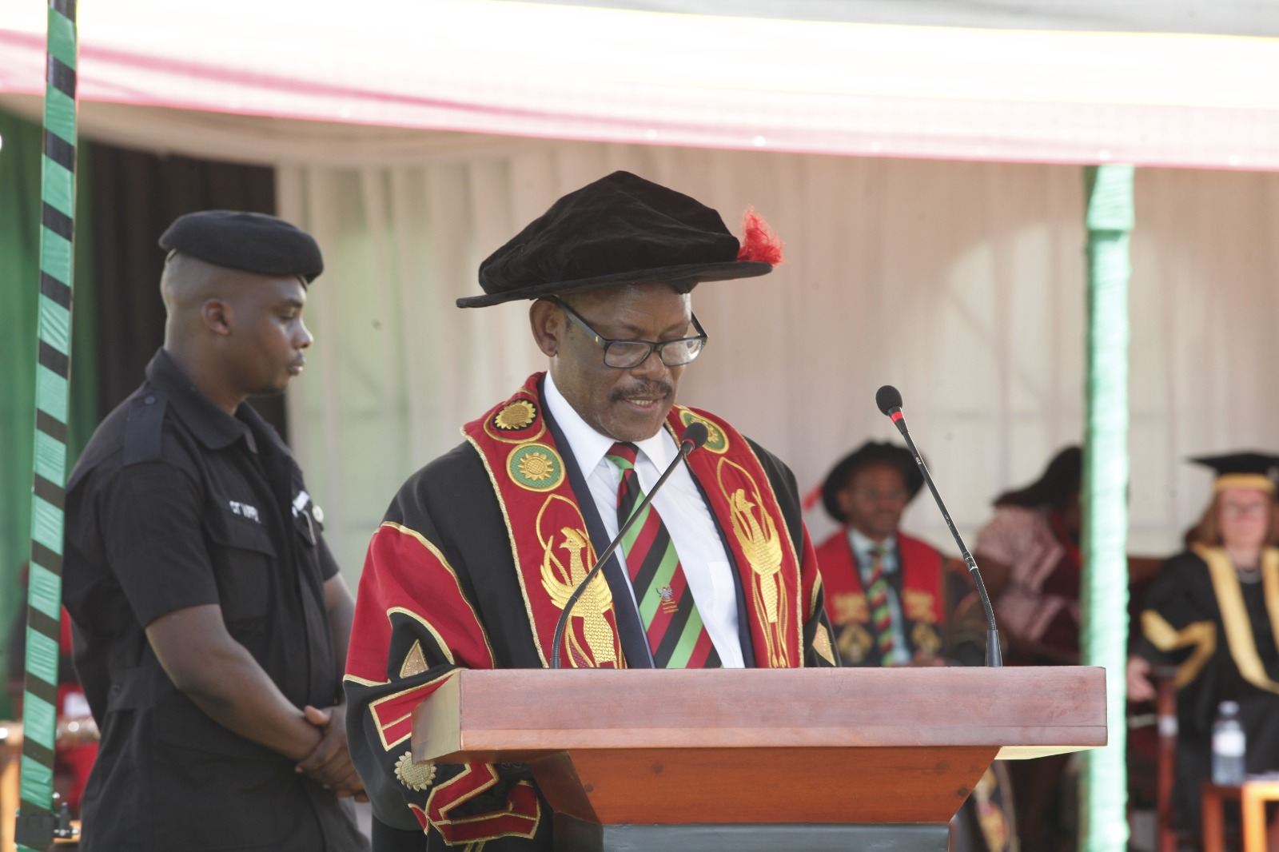
Professor Barnabas Nawangwe, Vice Chancellor – Makerere University

The Vice Chancellor highlighted that despite the disruptions occasioned by Covid-19, Makerere University is on a steady course of transforming into a research-led university as a result of the support from government and development partners. Professor Nawangwe commended government for the support through Research and Innovation Fund (RIF). Prof. Nawangwe invited graduands, parents and guardians to visit the Makerere University Innovation Hub situated at Yusuf Lule Central Teaching Facility established through partnership with the United Nations Development Programmes (UNDP). The hub is aimed at skilling students, supporting brilliant ideas and innovation for start-ups and creating jobs.
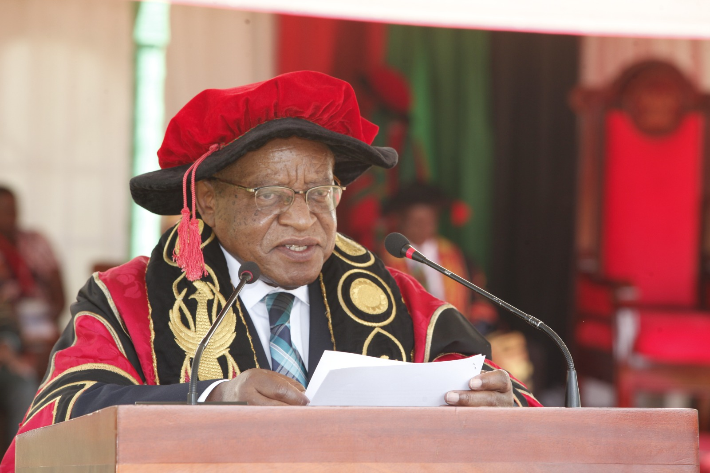
Professor Ezra Suruma, The Chancellor – Makerere University

In his remarks, Professor Ezra Suruma – Chancellor, Makerere University congratulated graduands upon making it to the 73rd Graduation Ceremony of Makerere University and achieving what you came to do when you joined the University. Prof. Suruma commended the First Lady/Minister of Education and Sports for the continuous support extended to Makerere University, requesting the congregation to join him and give her a warm applause. ‘I wish to recognize the efforts of the staff and faculty for the excellent work done to prepare the students graduating today despite the multiple challenges’ he added. The Chancellor pleaded with the graduands to never forget to cherish and to honour parents, guardians and sponsors who have sacrificed so much for them to reach this graduation day. He implored the graduands to cultivate an attitude of gratitude as you enter the world.
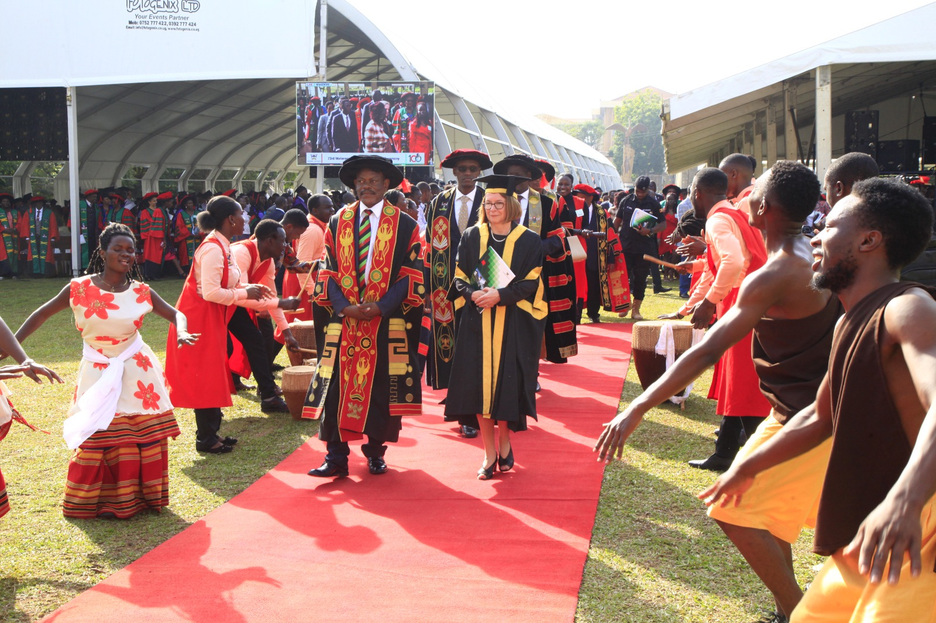
Professor Barnabas Nawangwe, Vice Chancellor – Makerere University and Professor Wendy Thomson in the procession to the 73rd graduation of Makerere University

The Vice Chancellor of the University of London, Professor Wendy Thomson, CBE delivered the commencement address to the congregation. She congratulated the graduands noting that it is a very important milestone in life, ‘an amazing achievement at any time but particularly given the challenges placed on study and health care services during the pandemic’. Professor Thomson said, ‘This is my first visit to Uganda which makes this a special pleasure for me personally and a welcome opportunity to renew the historical ties between the University of London and the University of Makerere.’
Professor Thomson advised the graduands that, ‘Yes, you are graduating into a complicated world, in one of the world’s poorer nations, but you are the people who, through your social and technical contribution, can reshape it into something more human, more prosperous, something more equitable, something better for us all. Be critical. Be kind. And stay curious.

Professor Christopher Curtis Whalen from the University of Georgia, U.S.A was awarded the Honorary Doctorate of Science in recognition of his contribution to health research and capacity building of Uganda, Makerere University and the College of Health Sciences. The orator, Professor Moses Joloba, noted that Professor Whalen has garnered over $90million for research in Uganda.
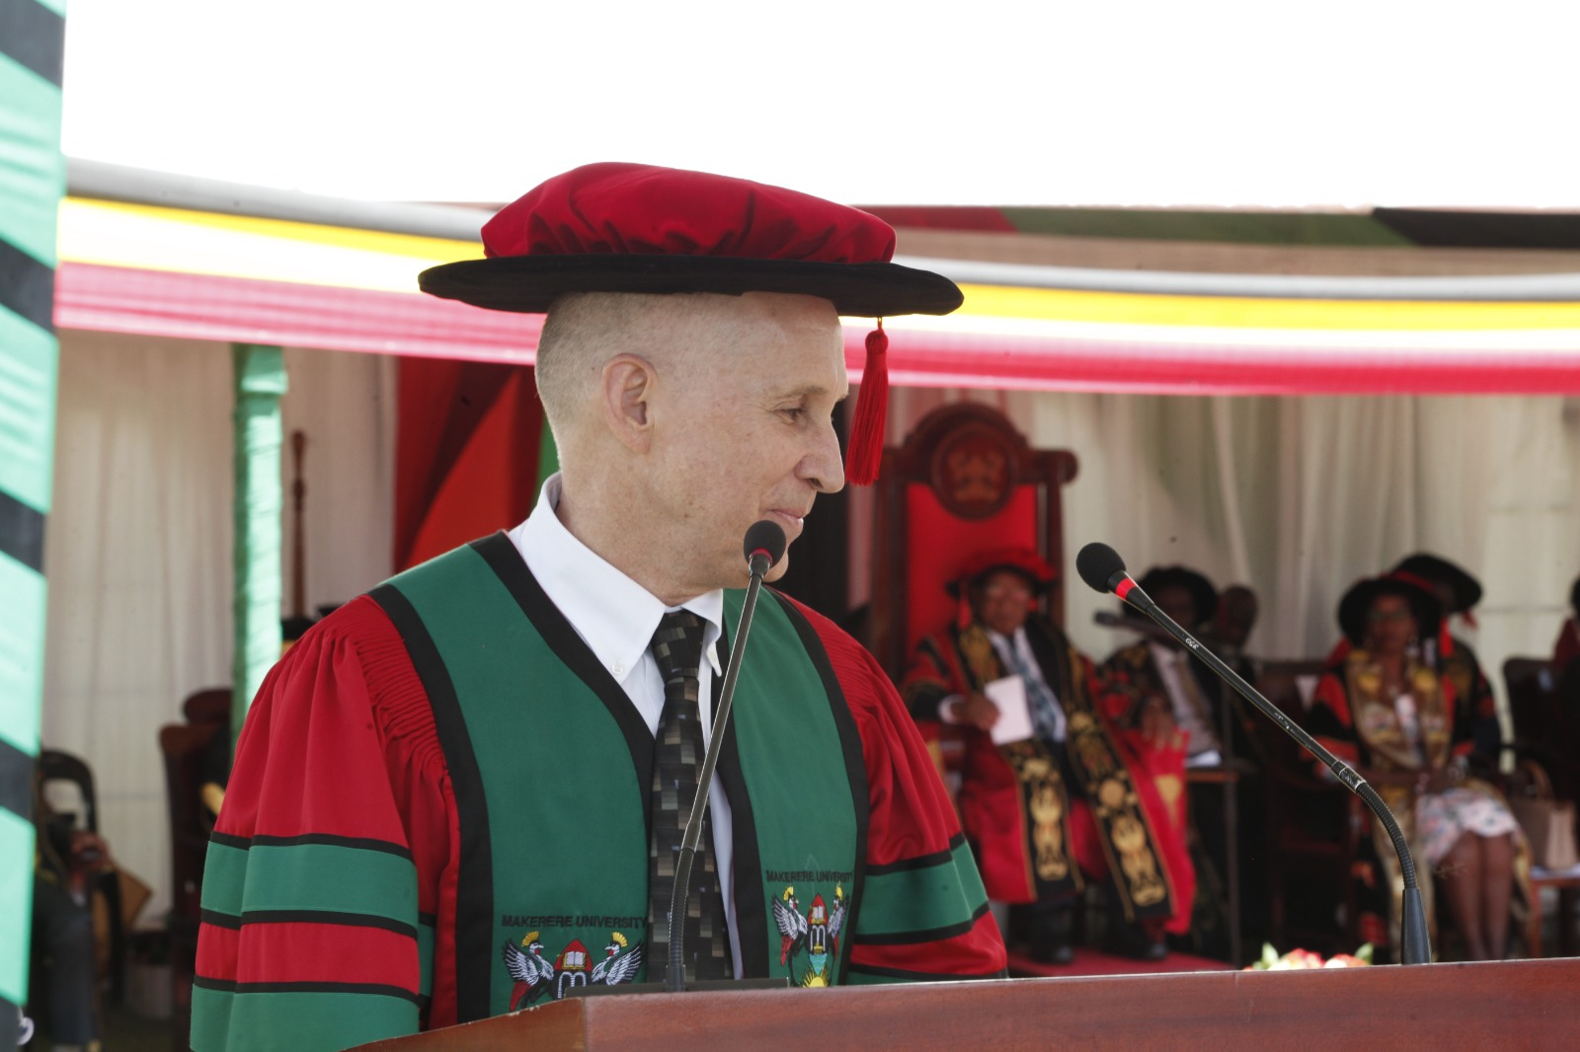
Professor Christopher Whalen

The First Lady and Minister for Education and Sports - Hon. Janet Kataaha Museveni attended the graduation ceremony virtually.
In her remarks, Hon. Janet Kataaha Museveni congratulated the graduands for accomplishing their studies applauding the parents and guardians for supporting the students noting that it is a sacrifice. Quoting the Bible, Jeremiah 1:5, she advised the graduands to set a personal life mission to guide their career path noting that purpose predates conception. The Minister added that her prayer for all the graduands is ‘to do what is intended for them with humility and be humble’. Hon. Kataaha Museveni applauded Makerere Council and Management for their strategic plan which is geared to increasing graduate students enrollment and thanked the University for being great partner to government, reiterating the government’s support. ‘I wish all of you blessings as you head out in the world to your career journey’ the Minister added.
During the 73rd graduation week running from the 13th – 17th February, 2023, a total of 13,209 students will be awarded degrees and diplomas in various disciplines. Of these, 102 will receive PhDs, 1,378 Masters Degrees, 35 ordinary diplomas, 108 postgraduate Diplomas, and 11,586 Bachelor’s Degrees. 52% of the graduands are female and 48% are male. Beside the School of Law, the Colleges of Health Sciences and Natural Sciences also presented graduands on the first day of the 73rd Graduation Ceremony.

